Folding The Group Scarf
The scarf may also be referred to as a Neckerchief or Necker
You should take good care of your group scarf, making sure it is always neat and tidy.
It shows everybody to which group you belong and, if you look after it, you will be able to wear it when you are a Cub, Scout and Explorer Scout too.
Here is how to fold your group scarf neatly:
Iron the scarf so that there are no major creases, because of the nature of the material some small creases may remain.
Please get an adult to help you iron your scarf.
After the scarf is ironed, position it as per below:
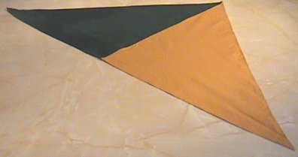
The scarf ready to roll
Lay your scarf flat on a clean surface.
There are two ways to ‘fold’ your scarf: you can either roll the scarf or actually fold it.
The one to choose is simply personal preference!

To roll the scarf:
Roll the scarf tightly from the centre smoothing out the ends as you go.
Try to ensure that the scarf remains the same tightness from the middle to the end.
It is quite easy to leave one of the ends behind! Try to maintain the consistency.
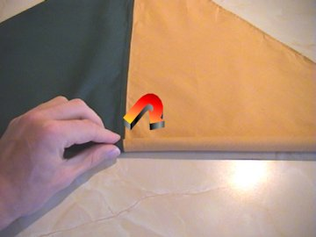
Rolling the scarf
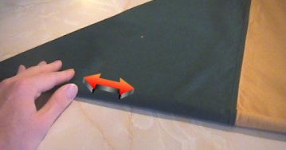
Smoothing the scarf
Continue rolling until the point of the scarf is about as long as your hand span.
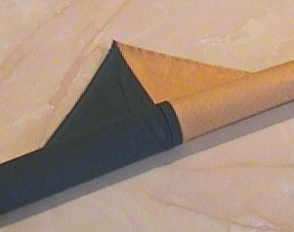
The point of the scarf
You will find that the scarf is quite bulky if rolled, so it is best to then iron the scarf flat.
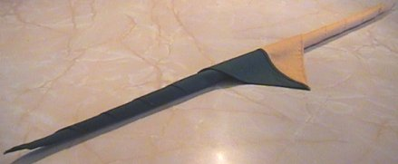
The scarf after being rolled
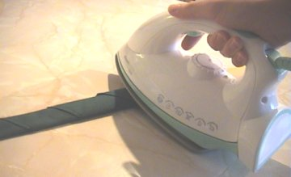
Ironing the scarf flat
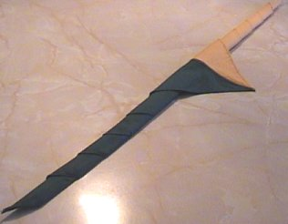
The scarf after being ironed

To fold the scarf
Fold the scarf over at 1cm intervals.
Try to keep this consistent or else one end may end up bigger than the other.
The first two folds may be quite difficult to align but after this it should almost fall into place.
To really keep the scarf looking smart, you may want to iron the scarf every few folds.
Folding the scarf
Keep folding until the scarf is about as long as your hand span.

Finishing
For both methods, you should now pitch the centre of the scarf and smooth the scarf as shown below.
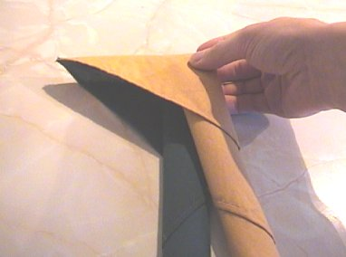
Finding the middle
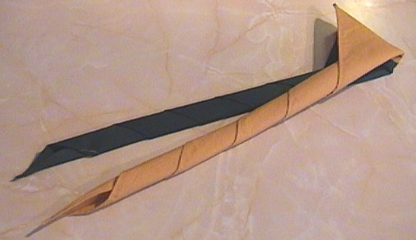
The folding of the scarf has now been completed

